Q1: Implementing an RNN for Text Generation

Task: Recurrent Neural Networks (RNNs) can generate sequences of text. You will train an LSTM-based RNN to predict the next character in a given text dataset.

- Load a text dataset (e.g., "Shakespeare Sonnets", "The Little Prince").
- Convert text into a sequence of characters (one-hot encoding or embeddings).
- Define an RNN model using LSTM layers to predict the next character.
- Train the model and generate new text by sampling characters one at a time.
- Explain the role of temperature scaling in text generation and its effect on randomness.

Hint: Use tensorflow.keras.layers.LSTM() for sequence modeling.

Q2: Sentiment Classification Using RNN

Task: Sentiment analysis determines if a given text expresses a positive or negative emotion. You will train an LSTM-based sentiment classifier using the IMDB dataset.

- Load the IMDB sentiment dataset (tensorflow.keras.datasets.imdb).
- Preprocess the text data by tokenization and padding sequences.
- Train an LSTM-based model to classify reviews as positive or negative.
- Generate a confusion matrix and classification report (accuracy, precision, recall, F1-score).
- Interpret why precision-recall tradeoff is important in sentiment classification.

Hint: Use confusion_matrix and classification_report from sklearn.metrics.

Question 3: Convolution Operations with Different Parameters

Task: Implement Convolution with Different Stride and Padding
Write a Python script using NumPy and TensorFlow/Keras to perform convolution on a 5×5 input matrix using a 3×3 kernel with varying parameters.
- Define the following 5×5 input matrix:
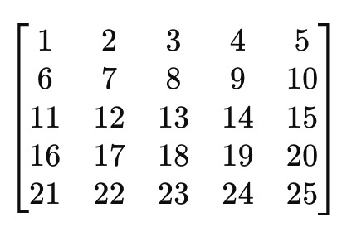
- Define the following 3×3 kernel:
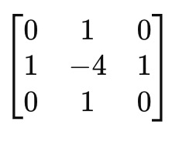
- Perform convolution operations with:
  - Stride = 1, Padding = ‘VALID’
  - Stride = 1, Padding = ‘SAME’
  - Stride = 2, Padding = ‘VALID’
  - Stride = 2, Padding = ‘SAME’
- Print the output feature maps for each case.

Expected Output

Print the output feature maps for
  - Stride = 1, Padding = ‘VALID’
  - Stride = 1, Padding = ‘SAME’
  - Stride = 2, Padding = ‘VALID’
  - Stride = 2, Padding = ‘SAME’

Question 4:
Implementing an RNN for Text Generation
Sentiment Classification Using RNN
Convolution Operations with Different Parameters
CNN Feature Extraction with Filters and Pooling

Task 1: Implement Edge Detection Using Convolution
Write a Python script using NumPy and OpenCV (cv2) to apply edge detection on an image using a Sobel filter.
- Load a grayscale image (you can use any sample image).
- Apply the Sobel filter for edge detection in the x-direction and y-direction.
- Display the original image and the filtered images.
Use the following Sobel filters:

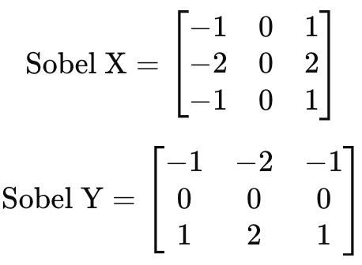

Task 2: Implement Max Pooling and Average Pooling (15 points)
Write a Python script using TensorFlow/Keras to demonstrate Max Pooling and Average Pooling.
- Create a random 4x4 matrix as an input image.
- Apply a 2x2 Max Pooling operation.
- Apply a 2x2 Average Pooling operation.
- Print the original matrix, max-pooled matrix, and average-pooled matrix.

Expected Output
Task1: Edge Detection using Sobel Filter
- Display three images:
  - Original Image
  - Edge detection using Sobel-X
  - Edge detection using Sobel-Y
Task2: Pooling Operations on Random 4×4 Matrix
- Printed original matrix, max pooled matrix, and average pooled matrix.

Question 5: Implementing and Comparing CNN Architectures

Task 1: Implement AlexNet Architecture (15 points)
Write a Python script using TensorFlow/Keras to implement a simplified AlexNet model with the following layers:
- Conv2D Layer: 96 filters, kernel size = (11,11), stride = 4, activation = ReLU
- MaxPooling Layer: pool size = (3,3), stride = 2
- Conv2D Layer: 256 filters, kernel size = (5,5), activation = ReLU
- MaxPooling Layer: pool size = (3,3), stride = 2
- Conv2D Layer: 384 filters, kernel size = (3,3), activation = ReLU
- Conv2D Layer: 384 filters, kernel size = (3,3), activation = ReLU
- Conv2D Layer: 256 filters, kernel size = (3,3), activation = ReLU
- MaxPooling Layer: pool size = (3,3), stride = 2
- Flatten Layer
- Fully Connected (Dense) Layer: 4096 neurons, activation = ReLU
- Dropout Layer: 50%
- Fully Connected (Dense) Layer: 4096 neurons, activation = ReLU
- Dropout Layer: 50%
- Output Layer: 10 neurons, activation = Softmax
Print the model summary after defining it.

Task 2: Implement a Residual Block and ResNet (15 points)
Write a Python script to define a Residual Block and use it to build a simple ResNet-like model.
- Implement a function residual_block(input_tensor, filters) that:
  - Takes an input tensor.
  - Applies two Conv2D layers (each with 64 filters, kernel size = (3,3), activation = ReLU).
  - Includes a skip connection that adds the input tensor to the output before activation.
- Create a ResNet model that:
  - Uses an initial Conv2D layer (64 filters, kernel size = (7,7), stride = 2).
  - Applies two residual blocks.
  - Ends with a Flatten layer, Dense layer (128 neurons), and Output layer (Softmax).
Print the model summary after defining it.

Expected Output
The output should display:
- The model summary for AlexNet.
- The model summary for the ResNet-like model.

